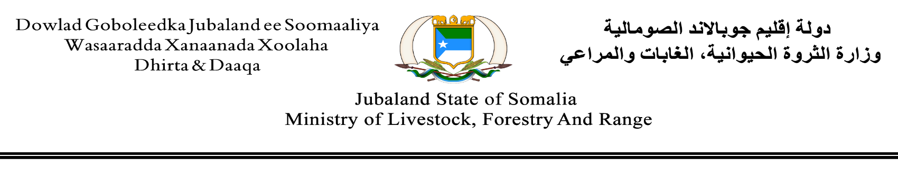

REF No: 022/MoLFR/JSS/2023 Date: 15/03/2023

TENDER NOTICE

REQUEST FOR BILL OF QUANTITY (BOQ)

Procurement of Goods for Midnimo poultry farm feeds, feeding equipment and nutrition supplements.
To: All Bidders of Interest
1. Ministry of Livestock, Forestry and Range Jubaland State of Somalia (JSS) has set aside funds provided by GIZ programme to be used to cover eligible payments under the contract for which this invitation for quotation is issued.
2. Eligible Bidders are hereby invited to submit their Bill of QuantityPurchasing and. As described in the Invitation for Bid.
3. All quotations in one original plus two copies, properly filled in, and enclosed in plain envelopes marked “BOQ No.022/MoLFR/JSS/2023. Purchasing of Goods as described in the specification form
4. The bid documents and supplementary documentation must be received not later than 6th April 2023 at 5:59AM Hours East Africa Time.
5. Quotations will be opened promptly thereafter in Public and in the presence of Bidder representatives who choose to attend in the opening at the Conference Room of Ministry of Livestock, Forestry and Range – Jubbaland State.
6. Late quotations, portion of quotations and quotations not received, quotations not opened at the quotation opening ceremony shall not be accepted for evaluation irrespective of the circumstances.

SpecificationRequirements
ITEM | DESCRIPTION | UNITS | QTY
1 | Chicken pen Maintenance (backfilling 3 rooms bottom surfaces destroyed by wind) | Chicken pens | 3
2 | 40 chicken lying nest installations | Chicken nest | 50
3 | Beneficiary training visibility banner | pcs | 1
4 | Provision of quality feeds and feeding containers to the birds (BOQ attached) | Poultry feeds | 1
5 | plantations of 15 shed trees | trees | 15
6 | Jubba water tap installation for the poultry farm with 50m hose plantation watering pipe | unit | 1
7 | Provision of 100 bags of sawdust (80kgs) | bags | 100
9
10
11
1.1.0
1.2.0
1.2.1
1.3.0

Interested companies/individuals are encouraged to visit MoLFR Main office for collection of BID Documents and apply BEFORE/On 6th April 2023 by adminfinhr@MoLFRjss.so / dg-molfr@jubalandstate.so or delivering to MoLFR main office.
Any enquiries or questions may be addressed to MoLFR Office, Tel no: 0614403899 / 0610300050 or adminfinhr@MoLFRjss.so / dg-molfr@jubalandstate.so

Mr. Abdullahi Hussein Ali
Admin, Finance & HR – officer
Ministry of Livestock, Forestry and Range Jubaland State of Somalia
_________________________________________

